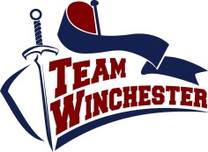
Winchester Student Union
Risk Assessment 2019/20

Sport/Society
Name
Committee Position
Signed
Date

Each organiser should nominate a person responsible for health and safety for their activity.

The nominated person responsible for this activity is:

(Activity Lead/Coach or Captain/Chair)
**INSERT NAME AND ROLE HERE**

Activity/Hazard | Person(s) at Risk | Risk |  |  | Control Measures | Risk Rating with controls
 |  | Worst outcome (a):  4. Possible death  3. Serious injury  2. First aid injury  1. Minor injury | Likelihood (b):  4. Very likely  3. Possibility  2. Unlikely  1. Remote | Risk rating:  (a x b = c)  1-2 = Very low  3-4 = Low  5-6 = Moderate  7-10 = High  10-16 = Critical

